
Training and Placement Cell (T&P)
Rajiv Gandhi University of Knowledge Technologies
Basar Campus, MutholeMandal, Adilabad District.
RGUIIIT-Basar/Placement/Notice Board/12/2017 Date: 04.08.16

DIAGNOTIC TEST FOR CRT BATCH-1 STUDENTS

It is hereby informed to all BATCH-1 (Chemical, CSE and Mechanical) students of CRT that there is DIAGNOSTIC TEST-1 scheduled as below:
date: 04-08-16
Time: Post dinner
Venue: Respective classes
It is mandatory for everyone to attempt the test and this will be monitor through online.

Website to Login: http://www.knowdedge.com/MainForm.aspx

Login Credentials:
Username: It is your college ID
Password: basara2017

Note: After getting login to your profile you need to change password.

STEP BY STEP PROCESS:

- Click on link you will get home there you can login.

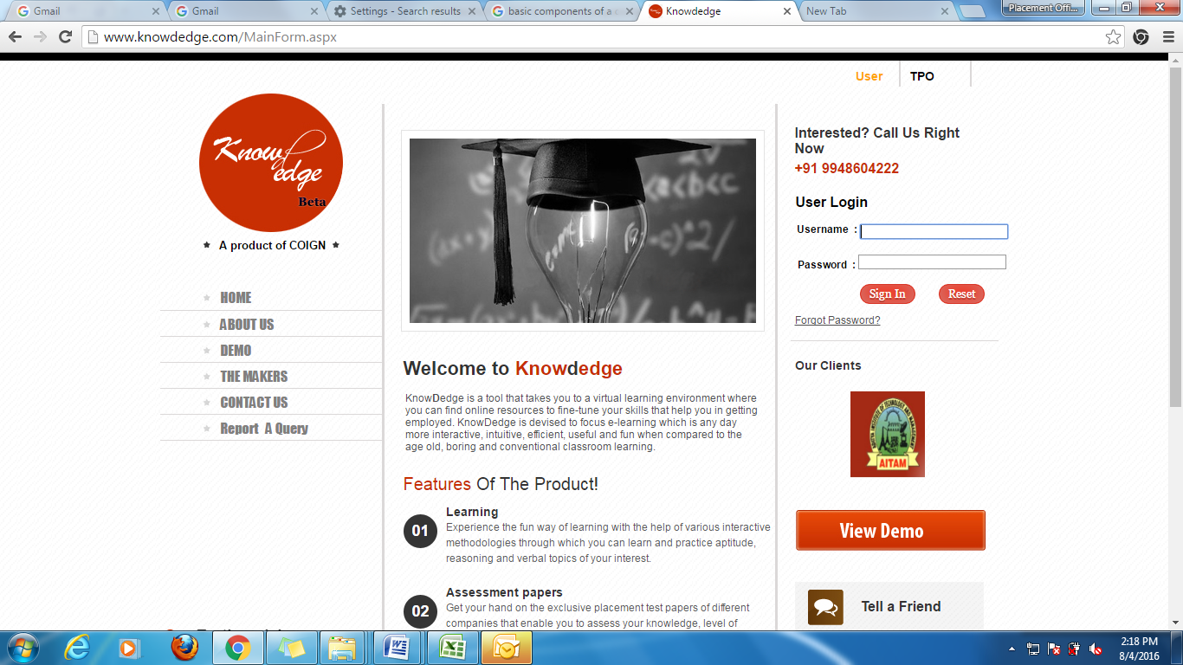
- Enter you details & click submit.
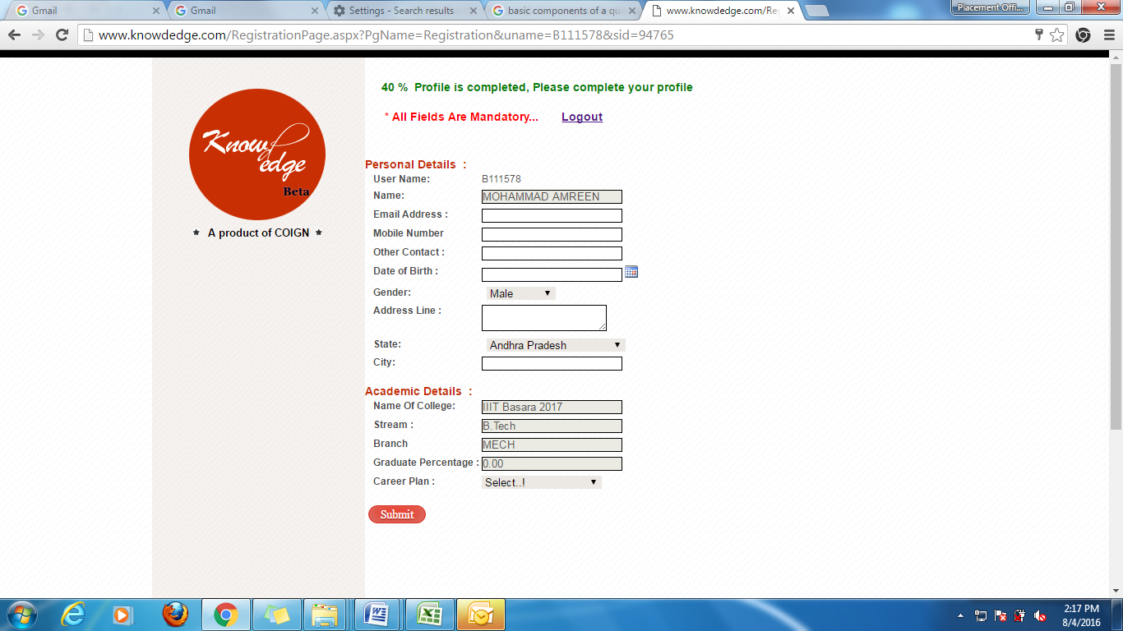

- After submitting the details you will get some fields like Learning, Assessments, Score card at top of the Home Page. Next click on Learning.
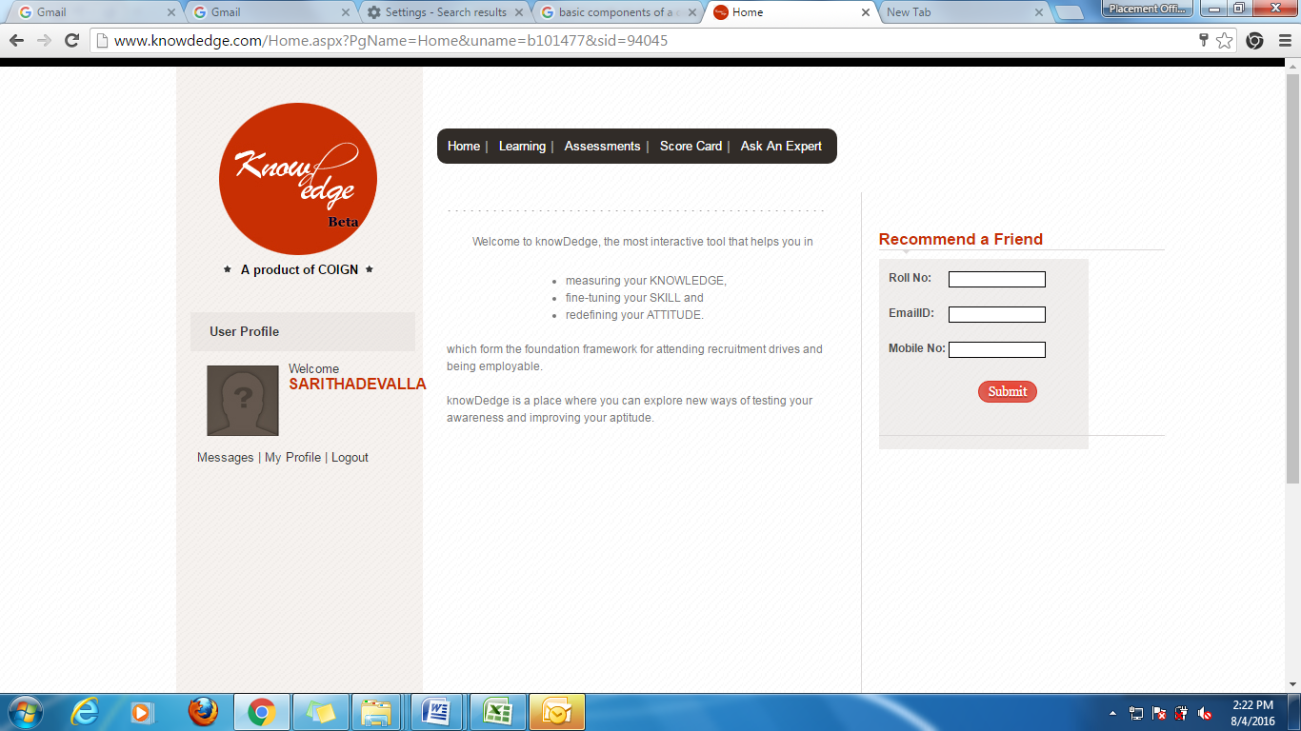

- Right side of the page you can see fields. Click on Assessment.
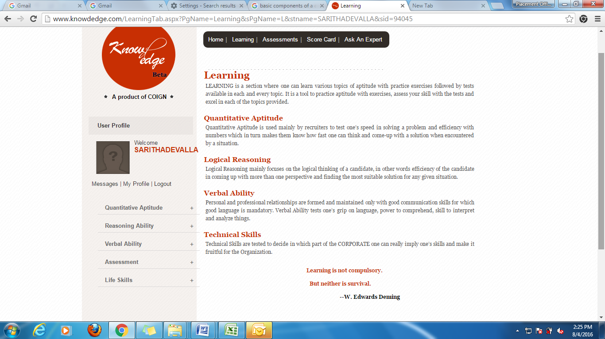

- Click on Diagnostic Test. Then click on take test.

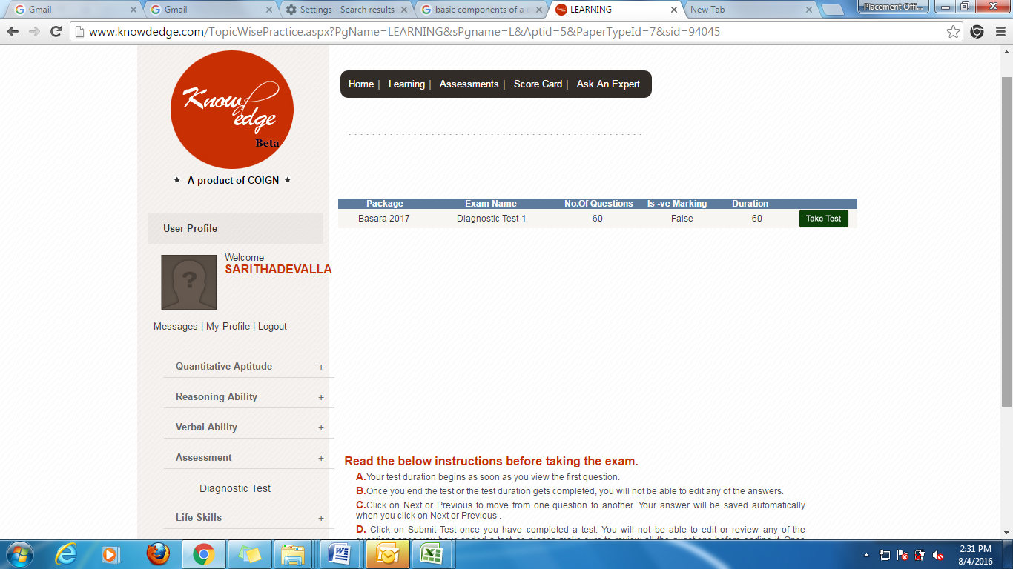

Sd/-
Placement Officer

