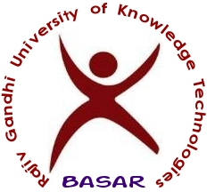

**T&P Office/Notice/20-21/256 Training and Placement Cell October 7, 2021**

**JOB ANNOUNCEMENT by Talentio**

Talentiowould like to recruit **CS & EC Engineering Graduates of 2020-21 for Technical Trainer Specialist**. The following is the detailed notification. Interested students are required to register in the following link by 12th October 2021 by 2PM.

**Registration Link:** <https://tinyurl.com/talrec2021>

And

<http://hub.rgukt.ac.in/hub/tnp/register>

We are offering employment opportunities to graduates & postgraduates of the **2018,2019,2020,2021 batch (All Branches)**who are passionate or have a flavour for teaching.

**Job Summery**

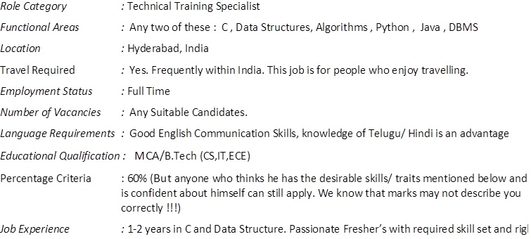

**Salary: 3 LPA**

**Job Description:**

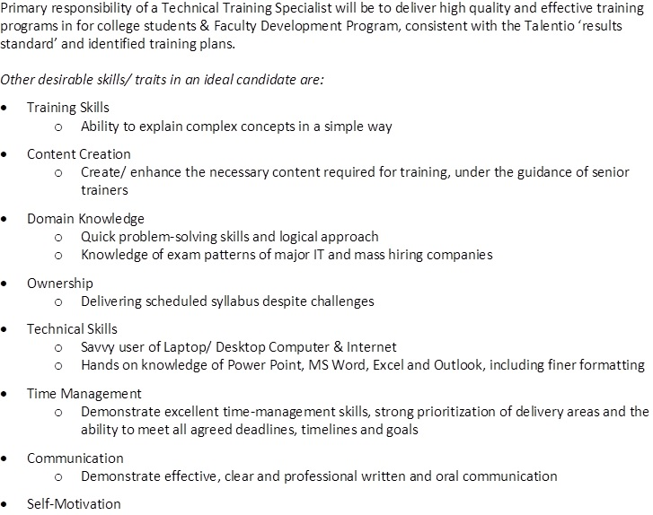

**The recruitment Process is as given below:**

* Google link to the unplaced students. <https://tinyurl.com/talrec2021>
* They will schedule an **online test** or  virtual interview based on convenience
* Results will be shared with the students on the same day
* Shortlisted students will go through technical and HR interview next day.
* Shortlisted students in the interview will receive the offer letter.
* Offered students are expected to join in 3-4 working days.

After successfully completing the training, you will be confirmed for Full-time employment.

Roles available:

1. **Technical & Non Technical Trainer**

**T & P Office**