
Training and Placement Cell (T&P)
Rajiv Gandhi University of Knowledge Technologies
Basar Campus, MutholeMandal, Adilabad District.
RGUIIIT-Basar/Placement/Notice Board/20/2017 Date: 09.08.16

DIAGNOTIC TEST FOR CRT BATCH-2 STUDENTS

It is hereby informed to all BATCH-II (MME,ECE & CE) students of CRT that there is DIAGNOSTIC TEST-1 scheduled as below:
date: 09-08-16
Time: Post dinner
Venue: Respective classes
It is mandatory for everyone to attempt the test and this will be monitor through online.

Website to Login: http://www.knowdedge.com/MainForm.aspx

Login Credentials for BTech:
Username: It is your college ID
Password: basara2017
Login Credentials for MTech:
Username: It is your college ID
Password: basara2015

Note: After getting login to your profile you need to change password.

STEP BY STEP PROCESS:

- Click on link you will get home there you can login.

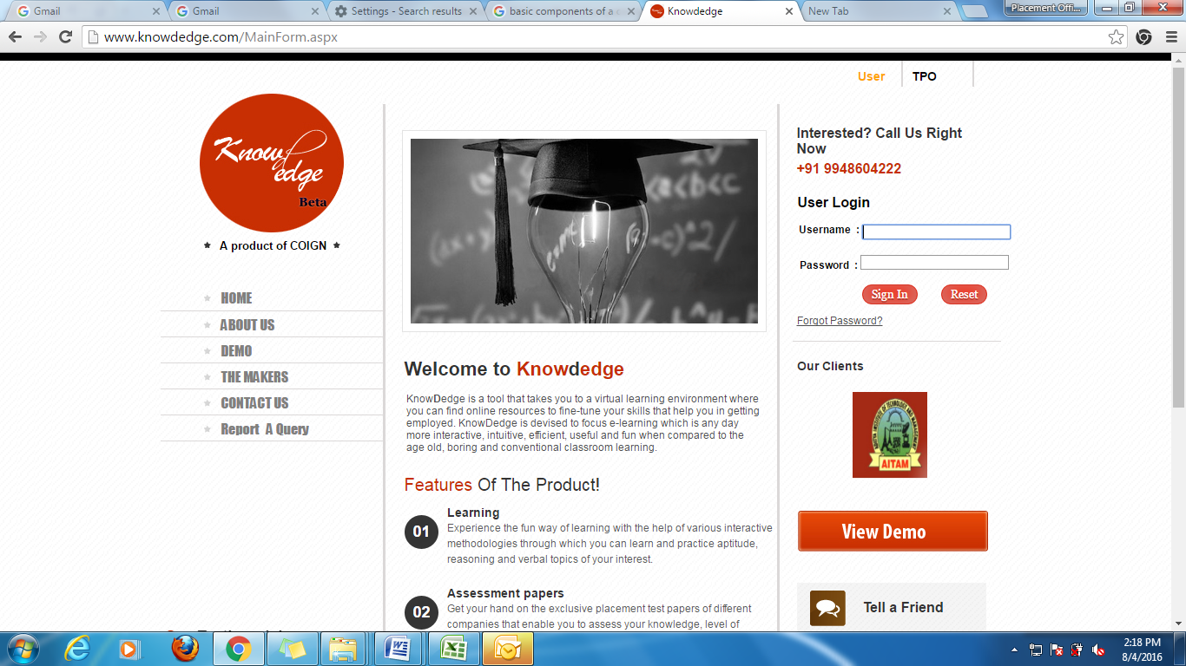
- Enter you details & click submit.
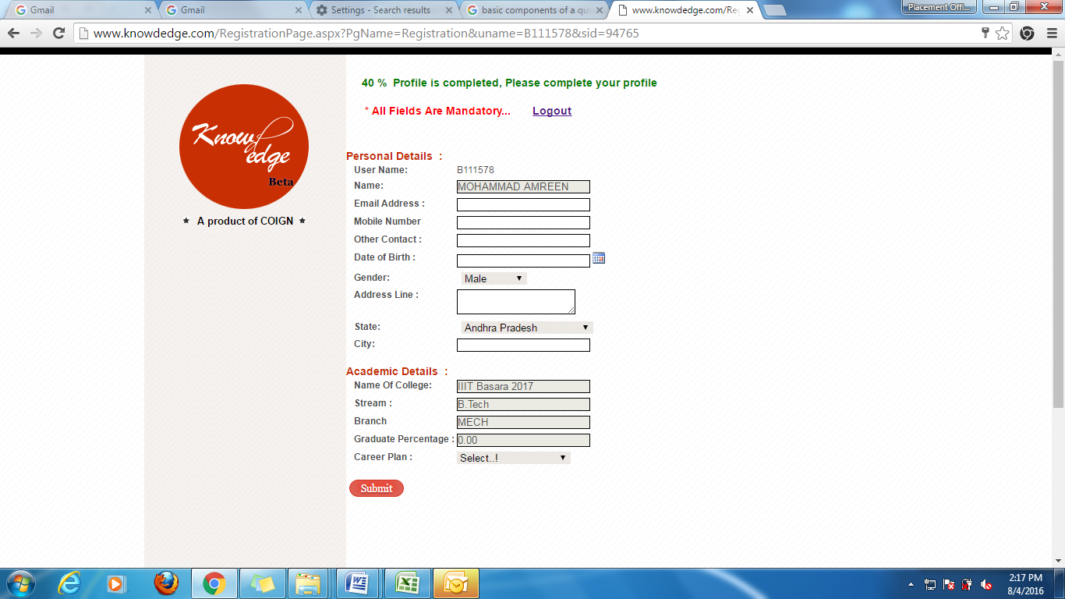

- After submitting the details you will get some fields like Learning, Assessments, Score card at top of the Home Page. Next click on Learning.
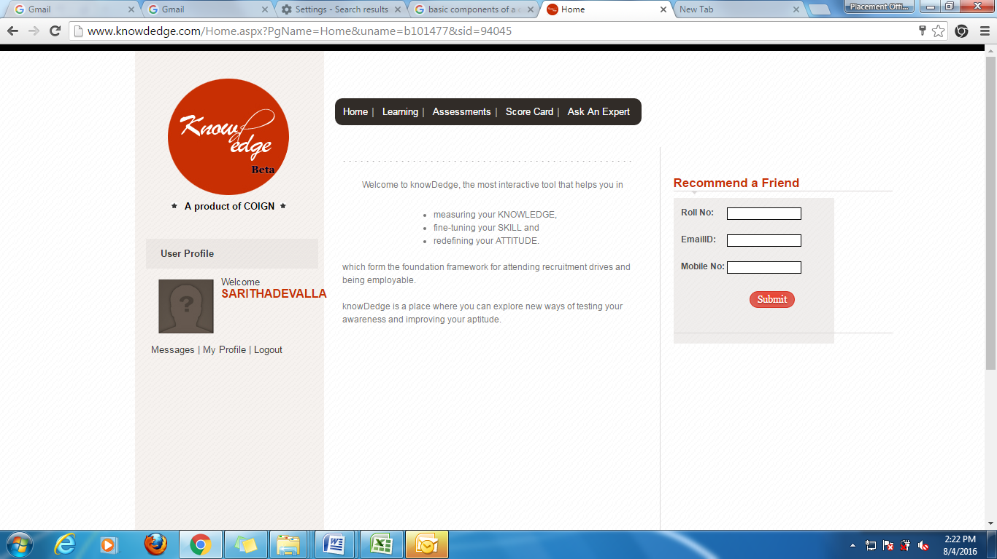

- Right side of the page you can see fields. Click on Assessment.
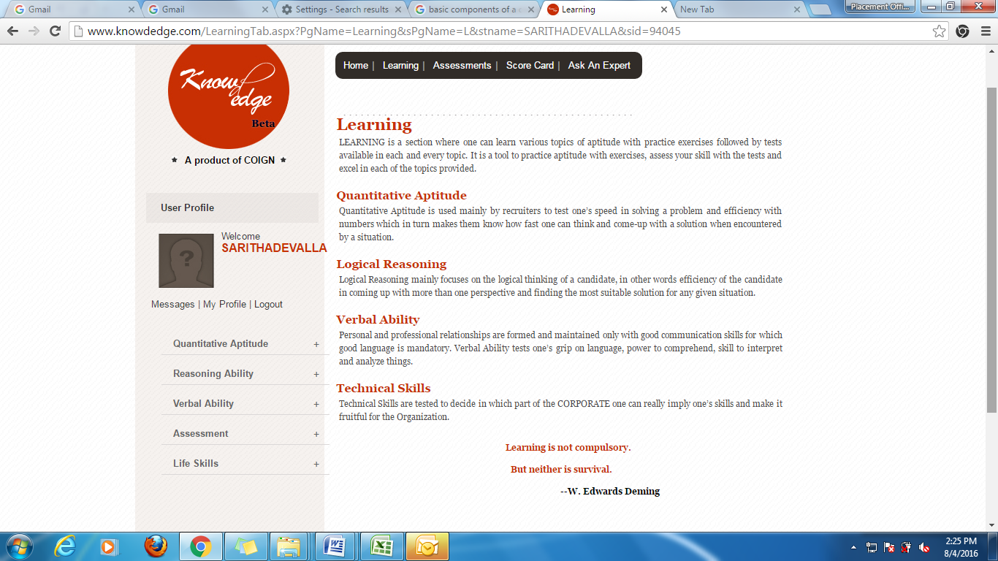

- Click on Diagnostic Test. Then click on take test.

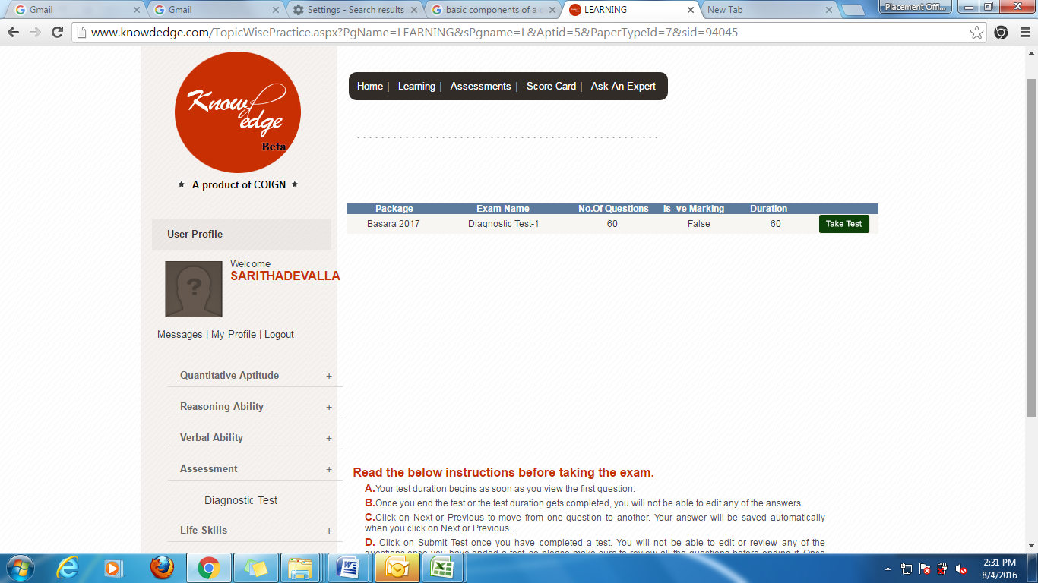

Time Table of CRT

 | Session - 1 |  | Session - 2 | 12.20-1.10 | Session - 3 |  | Session - 4
 | 9.20 am- 10.45am | BREAK | 11.00 am- 12.20pm | 12.20-1.10 | 1.30 pm- 2.50 pm | BREAK | 3:00 pm - 4.30 pm
Day - 1 | Employability Skills-1 | BREAK | Quantitative Aptitude | LUNCH | Verbal Ability | BREAK | Reasoning Ability
Day - 1 | Basics of Communication Skills | BREAK | Number Systems-1 | LUNCH | Basics of Grammer, SV Agreement | BREAK | Coding & De-coding
Day-2 | Quantitative Aptitude | BREAK | Employability Skills-1 | LUNCH | Verbal Ability | BREAK | Technical
Day-2 | Averages, Alligation Mixtures | BREAK | Goal Setting, Attitude Management | LUNCH | Articles, Prepositions, Voice | BREAK | C and Data Structure
Day-3 | Employability Skills-1 | BREAK | Quantitative Aptitude | LUNCH | Verbal Ability | BREAK | Reasoning Ability
Day-3 | Extempore-1 | BREAK | Number Systems-2, Lcm & Hcf | LUNCH | Tenses-1 | BREAK | Series & Sequence, Analogy
Day-4 | Quantitative Aptitude | BREAK | Employability Skills-1 | LUNCH | Verbal Ability | BREAK | Technical
Day-4 | Ratio Proportions, Partnership | BREAK | Body Language and Etiquettes | LUNCH | Sentence Correction, Speech | BREAK | C and Data Structure-1
Day-5 | Employability Skills-1 | BREAK | Quantitative Aptitude | LUNCH | Verbal Ability | BREAK | Reasoning Ability
Day-5 | Extempore-2 | BREAK | Profit & Loss | LUNCH | Tenses-2 | BREAK | Clocks, Classification
Day-6 | Quantitative Aptitude | BREAK | Employability Skills-1 | LUNCH | Verbal Ability | BREAK | Technical
Day-6 | Percentages | BREAK | Group Discussions-1 | LUNCH | Spotting Errors | BREAK | C and Data Structure-2

Sd/-
Placement Officer

