
Training and Placement Cell (T&P)
Rajiv Gandhi University of Knowledge Technologies
Basar Campus, MutholeMandal, Adilabad District.
RGUIIIT-Basar/Placement/Notice Board/79/2016 Date: 07.01.16

DevmenIT Announces 2016 Microsoft Office Specialist Championship

DevmenIT take the opportunity in providing the complete insight of the MOS World Championship in continuation to the introductory email sent earlier. Today we announce the 2016 Microsoft Office Specialist (MOS) Championship, the most popular technology skills competition for Microsoft Office since its inception in 2002. The popular Microsoft Office competition is the only one endorsed by Microsoft, providing a platform for students to showcase their expert skills using Microsoft Office tools and gain the upper hand in today’s competitive academic and professional marketplace. Winners of the 2016 MOS India Championship will be invited to the 2016 MOS World Championship in Orlando, Florida, USA on August 7-10, 2016.
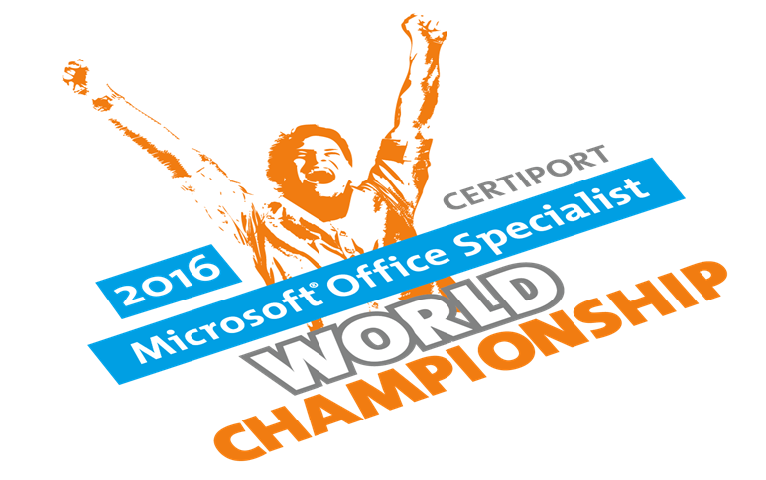
Eligibility:
Students aged 13 to 22 who attend an accredited learning institution. Students who compete in Microsoft Word, Excel and PowerPoint tracks for Office 2010 and 2013.


A video highlighting last year’s winners and their worldwide press coverage can be found http://www.moschampionship.com/past-competitions/ and the 2016 MOS World Championship promo video can be found here. Also, please find the attachment with the detailed proposal and the poster of the 2016 MOS Championship.

Sd/-
Placement Officer

