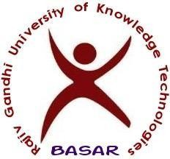
Rajiv Gandhi University of Knowledge Technologies
(A.P. Govt. Act 18 of 2008 & Telangana Govt. Adaptation G.O. Ms No.29 Dt.17.12.2014)
Basar (Village & Mandal), Nirmal District, Telangana State – 504107, India.

Webpage: www.rgukt.ac.in Training & Placement Cell
RGUIIIT-Basar/Placement/Notice Board/220/2018 Date: January 23, 2018

The final selects of NFTDC

1 | B121059 | SANKARAPU MANIKANTA | Mechanical Engineering
2 | B121598 | CHAKILAM BHANUPRASAD | Mechanical Engineering
3 | B121488 | MATURI RAGHUVEER | Mechanical Engineering
4 | B121720 | GURRAM SAI SAKETH | Mechanical Engineering
5 | B121789 | JUMBIDI UDAYKIRAN | Mechanical Engineering

Congratulations

Sd/-
Training & Placement Office

