

NDLI & NDLI Club member registration
Registration on NDLI website
- Click on the Link for registration https://ndl.iitkgp.ac.in/account/registration

- Use university mail id (Preferable)

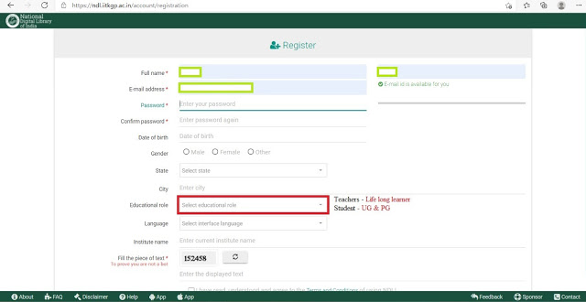
Fill all the above columns and click on Signup
- After completing the registration; visit your registered email ID and verify the email ID by clicking on the email received mail from NDLI.

- After user verification, Please login to https://ndl.iitkgp.ac.in/

Registration on NDLI Club website

- Click on the link https://club.ndl.iitkgp.ac.in/sign-up

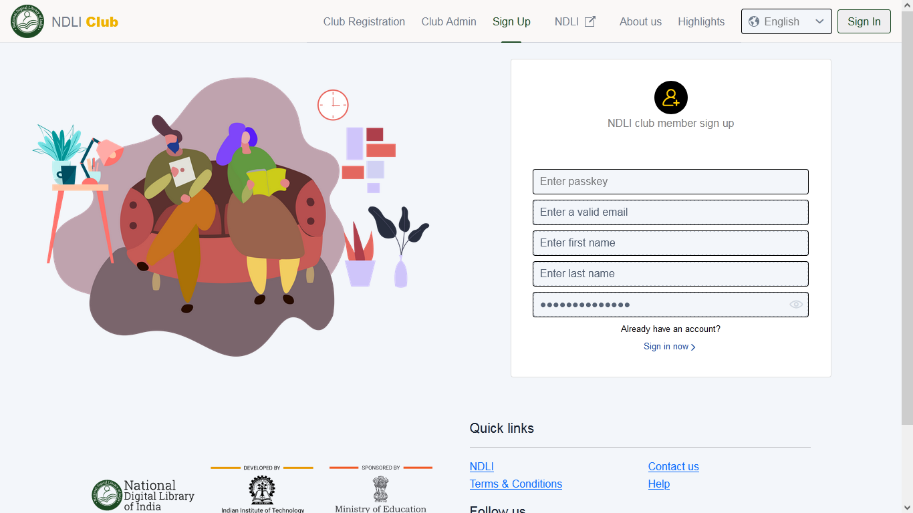

- Please enter passkey: 4c2ae617-9bb6-42eb-8955-23d77971fe64 ( Only for RGUKT Students & Staff)

- Enter registered email address
- no need to enter the first name, last name & password because the same is already entered during NDLI registration.
- Once the email ID is entered, a verification email will be sent to the registered email ID.
- Visit your email and verify the link send by verify the email ID by clicking on the email received from NDLI culb.
- Please login to https://club.ndl.iitkgp.ac.in/sign-in
- Verify/edit your profile 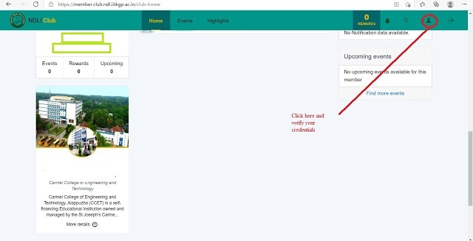

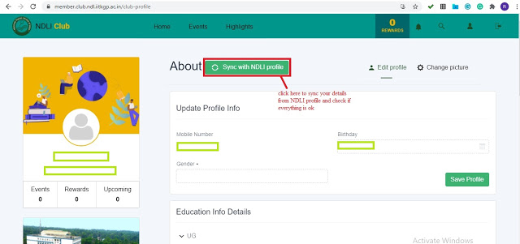
Finally click on “save profile”.
Contact :
Archana P
Technical Assistant
Central Library
RGUKT- Basar

