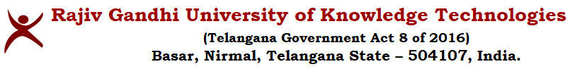
A.Y. 23-24_E3_SEM2_MECHANICAL ENGINEERING LAB EXAM (EXTERNAL) TIMETABLE

20/04/2024

This is to inform that the Regular lab Exams (External) for AY23-24 E3_Sem2 laboratory courses are scheduled as follows:

Date | Year & Sem | Subject code | Name of lab | Session-I | Session-II | Allocated Lab Staff
23/04/24 | E3_Sem2 | ME3801 | Heat Transfer Lab | C3_Batch 1 | C3_Batch 2 | B. Ramesh Chandra,
 |  | ME3802 | Computer Aided Engineering Lab | C2_Batch 1 | C2_Batch 2 | K. Jagadeeshwar
24/04/24 | E3_Sem2 | ME3801 | Heat Transfer Lab | C1_Batch 1 | C1_Batch 2 | B. Ramesh Chandra,
 |  | ME3802 | Computer Aided Engineering Lab | C3_Batch 1 | C3_Batch 2 | K. Jagadeeshwar
25/04/24 | E3_Sem2 | ME3801 | Heat Transfer Lab | C2_Batch 1 | C2_Batch 2 | B. Ramesh Chandra,
 |  | ME3802 | Computer Aided Engineering Lab | C1_Batch 1 | C1_Batch 2 | K. Jagadeeshwar

Note: The timings for the lab exams are as follows:-

HT Lab: Session-I - 9:30 am to 11:30 am & Session-II - 2:00 pm to 4:00 pm
CAE Lab: Session-I - 9:30 am to 12:30 am & Session-II - 2:00 pm to 5:00 pm.

Sd/-
Head of the Department
Mechanical Engineering.

