
Who ? Students of E3
Where: AB- I 313
When: 29/1/18
Time: 5:00 pm – 6:00 pm
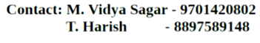
For further details:

-Team Trinayana 2K18

