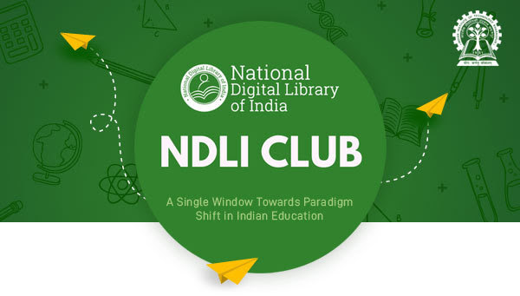

|  |  |  |
| --- | --- | --- |
| Dear NDLI Club Authorities,  On this day in 1947, our nation was finally free. On this 75th anniversary of our Independence Day, we remember the patriots who gave us the freedom we revel in today. The freedom to speak, do, be. The freedom to learn.  The Article 21A of our constitution mandates the Right to Education for every citizen of our nation. The National Digital Library of India carries that torch forward, promoting the importance of learning for all and ensuring free access to the same.  This Independence Day, NDLI celebrates the freedom of our nation and the freedom to learn, share and grow.  #learnsharegrow #DigitalLibrary #OneLibraryAllOfIndia #IndependenceDay #75thindependenceday #AzadiKaAmritMahotsav #HarGharTiranga #freedom #RightToEducation  **LINK**: <https://www.facebook.com/NDLIndia/videos/3260638767491776/>   |  | | --- | | **Video Link :** [Click here](https://u4465288.ct.sendgrid.net/ls/click?upn=kSpqpeCkkusBvEluz0jn1RKwEC4hAJbdH-2F3xkeTGFwUQNfLfGC5ayFEAqL-2FvUgnrEgDw_XTlQWDZ8G7qDxiv5MNBQ9eSdiP4Wk8BQAJFtgDQTijsHYLPI0yopPwKrVoAcIv0vSzCODKJuWwB924SlirY-2BOSc2gtKIOrnLGwaIVe2bMwPGEDNCQc3wNMM3ZMDm2hBfa0E9gD08l1scSZu9dOEbQfDzAsUAMasRCLWpACO2GUBxbbq-2BMjvLe1GufZ4QJsGa9t7A1LfDdh-2Bja3TVZPoV28K5S3AX9lRdNpSEx9xspny5d9R670od0TCUBVE-2F6T4tBVidEY594EOu1f7R4e1XdMV2VhAlN-2Fn9Qc3am1cxfs9nCH4h8BUeIeEEb1TwUQMPG8Wqxgo9nZHMvc7Ysp1EL2rgzzkjpxuQPzMPJHRSZW-2Ftplmw5kIF1cOorPIZ5NadCd0d0KjFqMSDe6ni1S-2FskFlzKfBIacZ24RLe-2BdBECQw-3D) |  |  | | --- | | **Please Like and Share** | |
| **National Digital Library of India** *Indian Institute of Technology Kharagpur* |