
Who ? Students from classes P2 to E2 (boys & girls)
Where: SAC Auditorium
When: 29/1/18
Time: 5:00 pm – 7:45 pm
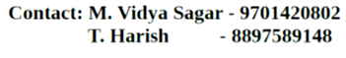
For further details:

-Team Trinayana 2K18

