
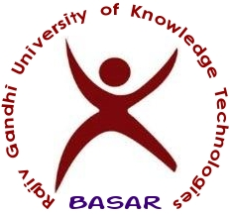

T&P Office/Notice/20-21/256 Training and Placement Cell October 7, 2021

JOB ANNOUNCEMENT by Talentio

Talentio would like to recruit CS & EC Engineering Graduates of 2020-21 for Technical Trainer Specialist. The following is the detailed notification. Interested students are required to register in the following link by 12th October 2021 by 2PM.
Registration Link: https://tinyurl.com/talrec2021
And
http://hub.rgukt.ac.in/hub/tnp/register
We are offering employment opportunities to graduates & postgraduates of the 2018,2019,2020,2021 batch (All Branches) who are passionate or have a flavour for teaching.

Job Summery

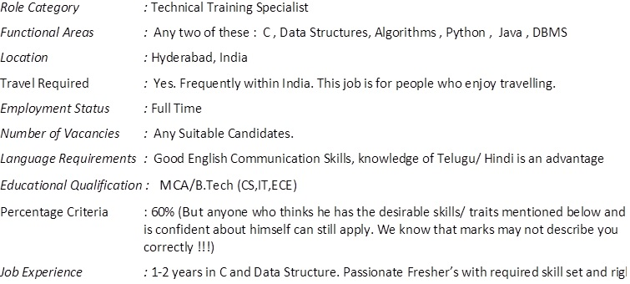

Salary: 3 LPA

Job Description:

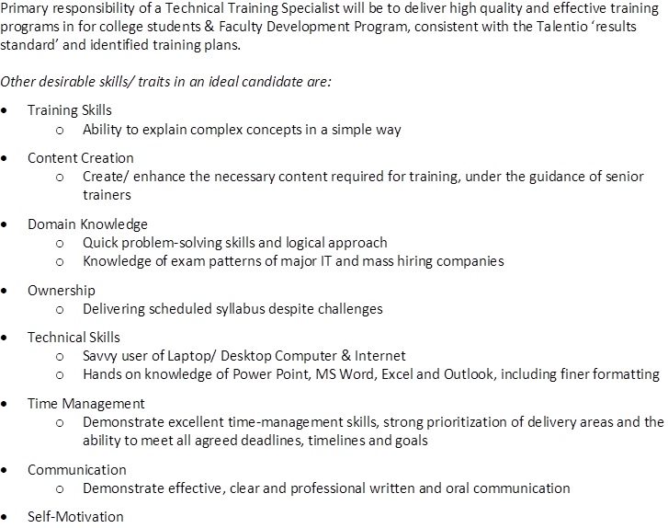
The recruitment Process is as given below:

- Google link to the unplaced students. https://tinyurl.com/talrec2021
- They will schedule an online test or virtual interview based on convenience
- Results will be shared with the students on the same day
- Shortlisted students will go through technical and HR interview next day.
- Shortlisted students in the interview will receive the offer letter.
- Offered students are expected to join in 3-4 working days.

After successfully completing the training, you will be confirmed for Full-time employment.

Roles available:

- Technical & Non Technical Trainer
T & P Office

