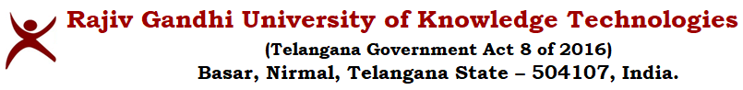

**A.Y 22-23_E4_SEM2_CHEMICAL ENGINEERING_TIMETABLE**

| **Year** | **Time** | **Mon** | **Tue** | **Wed** | **Thu** | **Fri** | **Sat** |
| --- | --- | --- | --- | --- | --- | --- | --- |
| **E4-C1** | Slot-1 |  |  |  |  |  |  |
| Slot-2 |  |  |  |  |  |  |
| Slot-3 |  | A | A |  | A |  |
| Slot-4 |  |  |  |  |  |  |
| **Lunch Break** | | | | | | |
| Slot-5 |  |  |  |  |  |  |
| Slot-6 |  |  |  |  |  |  |
| Slot-7 |  |  |  |  |  |  |

| **Slot-1** | 09:00AM-09:55AM |
| --- | --- |
| **Slot-2** | 10:00AM-10:55AM |
| **Slot-3** | 11:00AM-11:55AM |
| **Slot-4** | 12:00PM-12:55PM |
| **Slot-5** | 02:00PM-02:55PM |
| **Slot-6** | 03:00PM-03:55PM |
| **Slot-7** | 04:00PM-04:55PM |

|  | **Course code** | **Course Name** | **L-T-P** | **TOTAL CONTACT HOURS** | **FACULTY** |
| --- | --- | --- | --- | --- | --- |
| **A** | CH4251 | Process Optimization | 3-0-0 | 3 | Mrs. D. Srujana |
|  |  |  |  |  |  |

(Dr. Nammani Rakesh)

Associate Dean of Engineering



(Mr. Ravi Kumar Goud)

HoD, CHE

(Mr. B. Bhavsingh)

Faculty I/c

Overall Timetables

(Mr. S. Vinay Kumar)

Faculty I/c

Dept. Timetables