**Google Classroom Student Guide**

1. Go to classroom.google.com and click Sign In. Sign in with your Domain mail id.

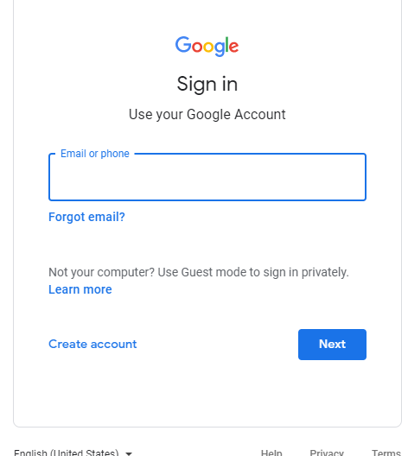

**Example: -**

Domain mail id : [**B211894@rgukt.ac.in**](mailto:B211894@rgukt.ac.in)

Password :**rgukt application id**

1. In the above domain mail an invitation link will be receiving from the respective subject as shown below and please click on the join to join the classroom.

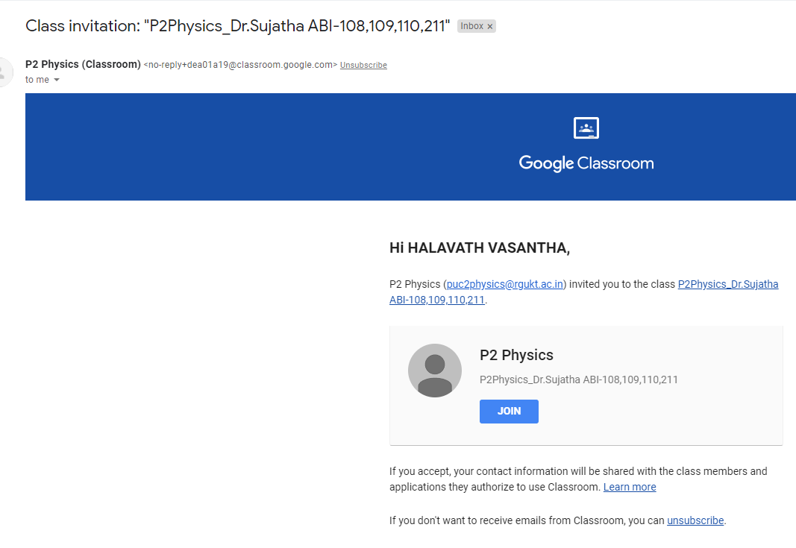

1. After clicking the join button as shown below pick up your role as student

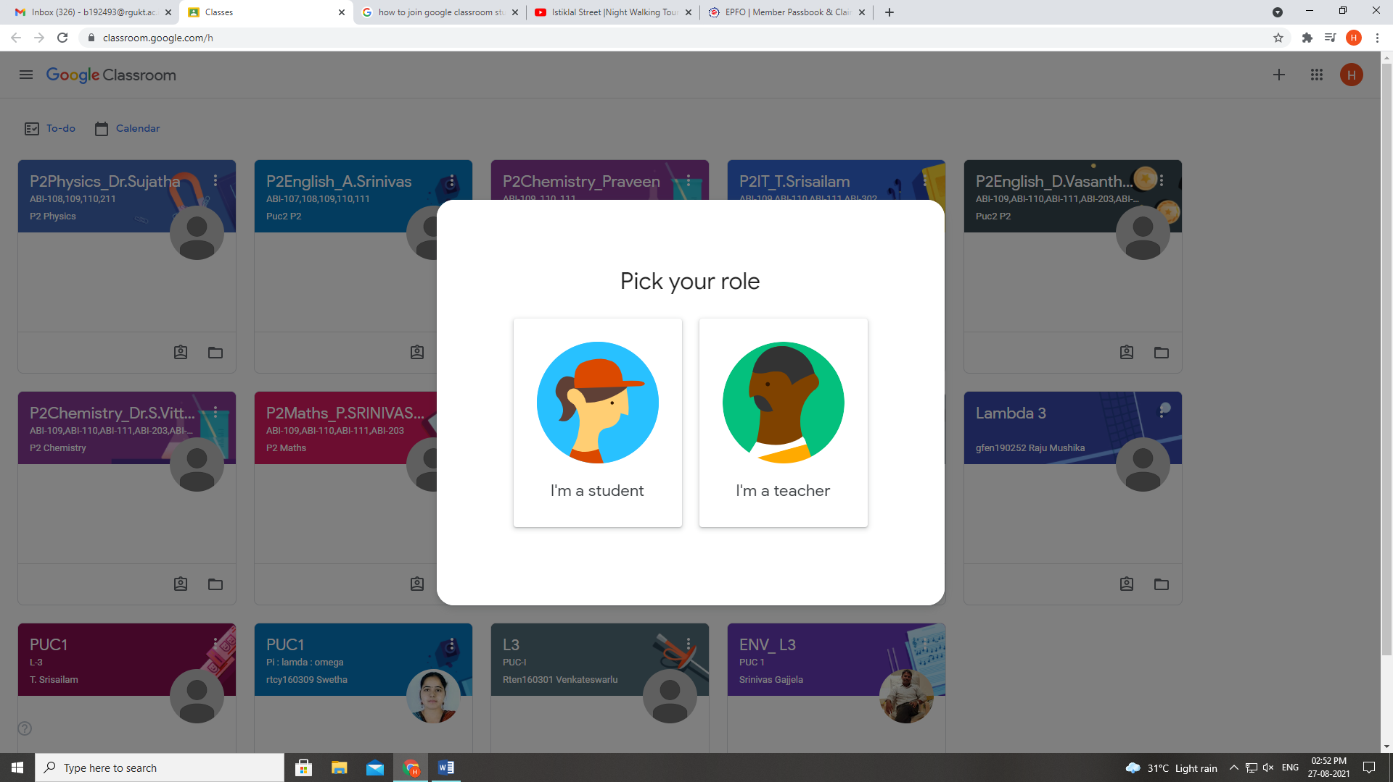

4. After picking the role as a student, as shown below subject, teacher and classroom will be displayed, please click on the subject name

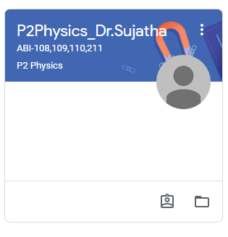

5. After selecting the subject name, as shown below class room content will be displayed

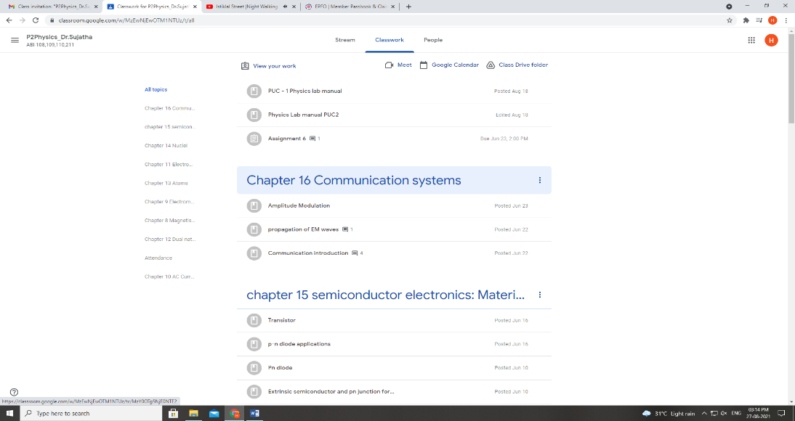

6. Students, who are using mobile phone to listen online classes must install Google Classrooms app.

7. While using mobile you may get invalid username and password because you already logged in with your personal mail id, so you go to your mail and select “Add another account”, there you can give rgukt domain mail id and password.

8. After submitting the credentials you must select your domain mail to use Google classrooms app.