**Rajiv Gandhi University of Knowledge Technologies**

**Basar, Telangana**

**Date: 15/07/2020.**

Dear All

We would like to bring to your notice that RGUKT-Basar campus has got enrolled with prestigious organization **“INDIAN INSTITUTE OF REMOTE SENSING – INDIAN SPACE RESEARCH ORGANISATION [ IIRS-ISRO ]**, Department of Space, Govt. of India for Online- Outreach Programme - Live ,Interactive & Learner centric e-learning courses for the benefit of staff and students.

IIRS Outreach Programme focusses on strengthening the Academia and User Segments in Space Technology & Its Applications using Online Learning Platforms. Under this programme the two mode of content delivery system is developed using online learning platform (i.e) Live & Interactive mode (known as EDUSAT) and e-Learning mode.

**For more Details visit:** [**https://elearning.iirs.gov.in/**](https://elearning.iirs.gov.in/)

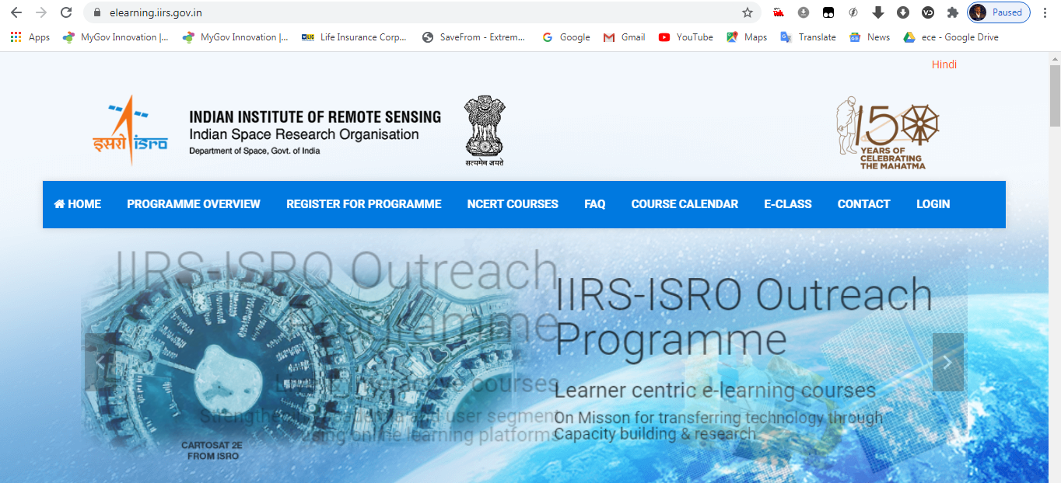

**For Registration Process visit:** [**https://elearning.iirs.gov.in/edusatregistration/student**](https://elearning.iirs.gov.in/edusatregistration/student)

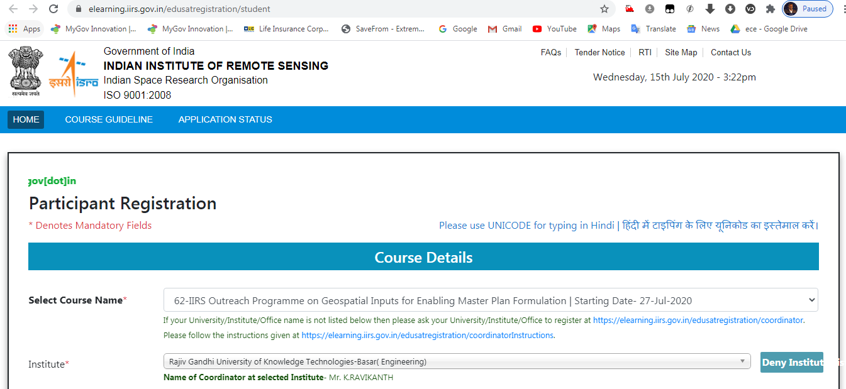

For more details contact IIRS-ISRO Campus Coordinator:

Mr.K.RAVIKANTH,

Assistant Professor,

Department of CSE- Ground Floor: Cabin.No: 06

Email: [ravikanth.iiit@rgukt.ac.in](mailto:ravikanth.iiit@rgukt.ac.in)

Mobile: 9247448766