Notice

As a part of Antahprgnya-2k18 Department of Mathematics is conducting the following four events. All the students who are interested in participating in the events go through the details of the events

1. Add Prime and Get Prime\
2. Crazy Cube
3. Math Chain
4. Pi Fibonacci

**Who can participate:**

All the students of the campus

**How to Register:**

The participants has to pay Registration Fee of Rs 10 /- and register their names in the class ABII-303 from 5:00pm-10:00pm

For Individual events the registration fee is Rs 10.

For Group events the registration Fee is (No.of members in the group) $×10$

**CRAZY CUBE:**

CRAZY CUBE is an open event in which participants are expected to make a pattern using Rubik's cube.

RULES:

1. The contest will be started with a solved cube

2. The participants should bring their own rubik's cube

3. This event consists of 2 level.

LEVEL 1:

1. Any one pattern from the below patterns will be given on the day of event*.*

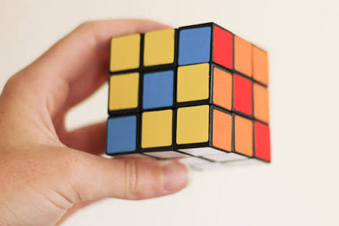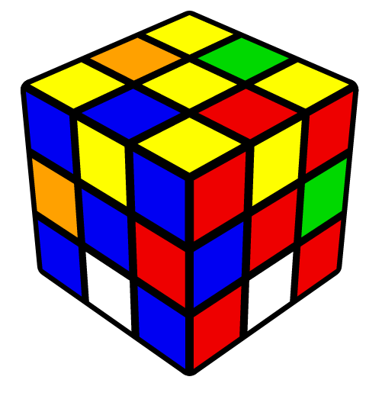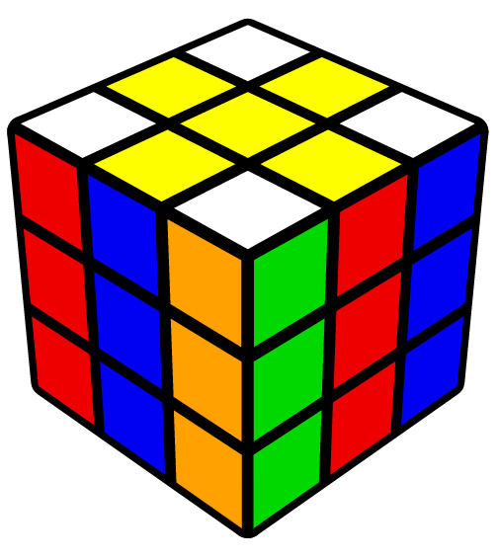

2. The participants should be taken to next level based on their solving speed.

**LEVEL 2:**

1. The pattern for this level is given on the spot

2. The winners will be announced based on their solving speed.

**ADD PRIME – GET PRIME**

ADD PRIME – GET PRIME is a contest in which participants are expected to identify Three primes from given set of numbers such that their sum is a prime

This contest will be conducted in two levels.

LEVEL 1:

1. In this level a list of numbers will be given.

2. Participant should identify the prime numbers and write a sum of three prime numbers in such a way that the sum should be again prime number.

3. Based on their speed, the participants can be taken to next level.

LEVEL 2:

1. In this level, participants will be shown 2 lists of prime numbers one after the another for 40 sec and the participant should remember those prime numbers and should write 2 sets of sums(each set should contain 3 prime numbers) in such a way that the sum should be again prime number
2. Each list consist of 9 prime numbers ( 2 or 3 or 4 digited numbers)

RULES

1. All the students of RGUKT can participate individually

2. Mobiles and calculators are not allowed

**PIE( $π)$– FIBONACCI**

**PIE - FIBONACCI is a contest the in which participant is expected to write the value of fibonacci sequence obtained from the value of Pi .**

**For example:**

**we know the value of pie i.e,**

**pie = 3.1 4 1 5 ....**

**(1+4) (5+1) (6+5)**

**pie fibonacci sequence = 3.1 5 6 11 ....**

**SOLVE THE CHAIN**

SOLVE THE CHAIN is an individual event in which participants will be given few questions and each question consist of 5 blocks. The participants are supposed to solve all the 5 blocks using given clues.

RULES:

1. All the clues will be given which are related to mathematics

2. All the students of RGUKT can participate and each team should consist of 4 members

3. NO electronic devices are allowed