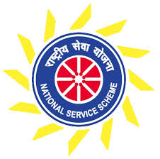



We are heartfully thanking you all for the best services whatever you contributed to this RGUKT

to realize the excact cause of social service and to give a support to

**ANTHAHPRAGNYA-2k18**

At last of the year to give a happy end we are here to entertain you all with various forms

and we also request you to participate in this Grand Eve and make it delightful

It is here by informed to all the nss volunteers to engage with the effective activity that is

going to be held on 17th and 18th (last but not the least)

**Main activities:**

1.Dust-bin Making (with higher efficiency) {made of paper or other else}

2.Plant Adoptation

3.Cultural Auditions

4.Upcoming year plannings etc..

**VENUE:** All voluteers must gather at Civil-Labs

**Date&Time:** 17th March 2k18 (4:30 pm for 17th )

**NOTE:** All the volunteers are mandatory and must should attend for the last two activities...



***THANKING YOU***

SD/-

T.Rakesh Reddy

(nss coordinator)