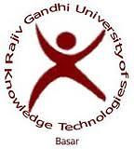
Training and Placement Cell (T&P)
Rajiv Gandhi University of Knowledge Technologies
Basar Campus, MutholeMandal, Adilabad District.
RGUIIIT-Basar/Placement/Notice Board/129/2016 Date: 10.03.16

JOB ANNOUNCEMENT OF BOSCH

It is hereby informed to all E4 students that Bosch conducting recruitment drive for mechanical students. Interested and eligible students need to register through a link provided in local hub.
Eligibility : Mechanical
CGPA: 60% & above throughout academics (no history of backlogs in any semester)
CTC: 4LPA
Joining: June or July 2016
Last date for Registration: 11-03-16, 4:00PM

Sd/-
Placement cell

