**RAJIV GANDHI UNIVERSITY OF**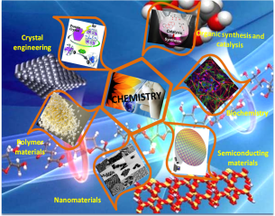

**KNOWLEDGE TECHNOLOGIES**

**BASAR, ADILABAD**

**TELANGANA – 504107­­**

**National Symposium**

**on**

***Recent Advances in Chemical & Material Sciences***

**(RACMS 2016)**

**Notice to Students**

The department of Chemistry, RGUKT – Basar organizing a two days national symposium on “RECENT ADVANCES IN CHEMICAL AND MATERIAL SCIENCES” on 20-21st of August 2016. The interested students who want to participate as volunteer can contact Dr Ravi Varala, HoD, Chemistry department at the given address.

Dr Ravi Varala,

HoD, Chemistry Department, RGUKT – Basar

Faculty Cabin number 61, 2nd Floor

Mobile number: 9618286529

Mail Id: ravivarala@rgukt.ac.in